NetSuite
Step 1 – Bills need to be approved by the Business Manager and Finance (Kyle Oakley). We save the backup with Bill in NetSuite and in an outside shared folder.

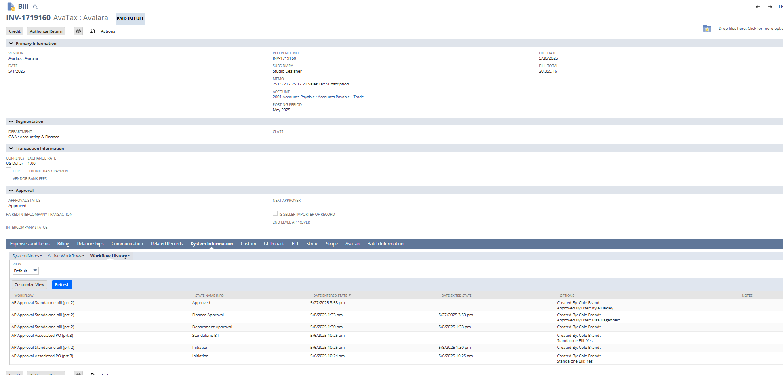
Step 2 – Once a bill is approved and it is put into a payment batch to generate a NACHA file for the bank. This payment batch also has to get approval from our Controller (Thomas Sutton)
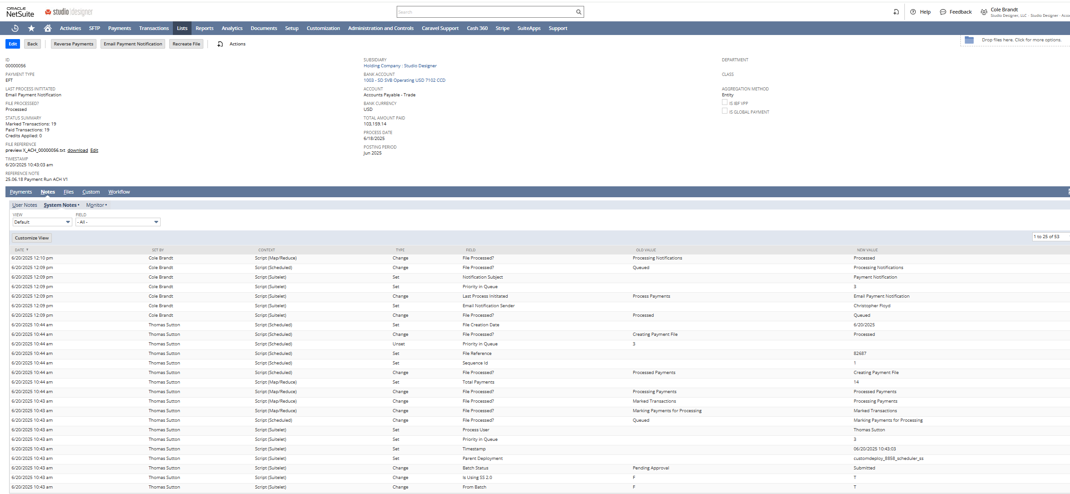

SVB Bank account
Step 3 – The file is pushed into Transact Global Gateway (Tag) at our SVB bank account. Below is the dashboard.
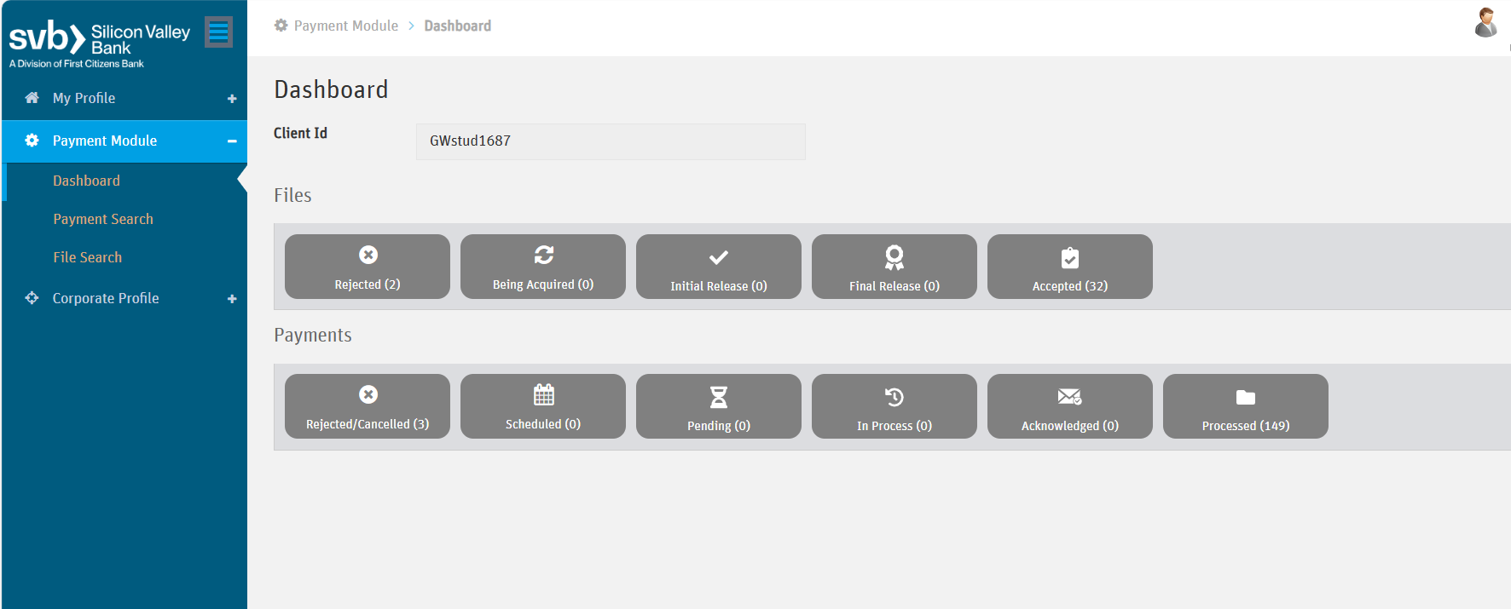

Step 4 – A file needs to get approval from the submitter to ensure accuracy and then a second approval from the CFO.

From a Bills approval to payment 6 different people see it and approve it.

